Presseinformation  Abdruck honorarfrei. Belegexemplar erbeten. | 

Function and design
for the building envelope
cocuPV: Metal shingles with integrated photovoltaics
In the planning and execution of a building, the building envelope is of key significance. It must not only comply with functional aspects, but also take into account high architectural standards. With “cocuPV”, Boehme Systems has developed a building element that can unify these components – and that can, moreover, be used to generate electricity: a novel component with an integrated photovoltaic panel, used to implement holistic building envelopes.
Building envelopes must not only satisfy the requirements of architects and safety and structural engineers, but must also fulfil aesthetic demands. Apart from their purely functional roles, therefore, facades and roofs take on important representative tasks. In addition, the flow of energy in the envelope is of central importance for architects and designers working in contemporary designed objects. Such innovative building envelopes should not only minimise heat loss and prevent overheating in summer, but, wherever possible, capture solar energy to improve the total energy balance of the building.
Metal shingles with integrated photovoltaics
To meet these diverse needs, Boehme Systems has developed a new component that combines functionality, design flexibility and energy efficiency: "cocuPV". The word "cocu" here stands for "complex-curved" (multidimensionally deformable). The special feature: in the photovoltaic element, a flexible solar panel is integrated into a metal shingle. In an industrial production process using vacuum lamination, the individual cells are filled in on the shingle itself – a procedure that ensures a consistently high quality standard on the one hand and, on the other hand, ensures that the cells need not be attached to the shingles with extra glue, eliminating the risk of damage to individual cells during the gluing. This method also rules out the accidental detachment of photovoltaic panels.

Energy generation through the building envelope
Using “cocuPV”, builders can create a visually appealing building envelope that can be used to generate energy at the same time – no additional roof or façade elements are needed. The All Light Performance system ensures that electricity is produced even in unfavourable weather conditions and is thus not restricted merely to the hours of pure sunshine. As well as energy efficiency, the new component from Boehme Systems also offers architects and planners a maximum degree of design freedom. “Thanks to its elasticity, even unusual, organic shapes can be realized with cocuPV. Since the photovoltaic cells are integrated, the appearance of the building is not disturbed by additional photovoltaic panels", explains Andreas Stengl, Managing Director of Boehme Systems Vertriebs GmbH.
Straightforward processing
Installation is very simple: the individual shingles can be slid easily into each other along their edges and attached using the special clips from Boehme Systems. To create a unified overall appearance, cavities are covered over with dummy shingles. In this way, widely varied roof and façade forms can be built – no matter whether a classic pitched roof, a flat roof, or a roof made of flowing, curved surfaces.
Approx. 3,200 characters

About Boehme Systems:
Boehme Systems Vertriebs GmbH specialises in the development, manufacture and supply of innovative building claddings made from metal. The company sees itself as a system provider who develops solutions for facades and roofs that make architectural and economic sense, giving due consideration to all important surrounding factors. The products are manufactured in the company’s own production facilities which are equipped with state-of-the-art technologies. In addition to standardized solutions from its extensive product portfolio, Boehme Systems repeatedly develops individual solutions that offer architects and tradesmen a maximum degree of design freedom. A team of master tradesmen, fitting instructors, engineers and technicians ensure competent advice and service – from planning to execution.

Note:
This press release can also be downloaded at www.boehme-systems.com and www.Kommunikation2B.de.

Captions:
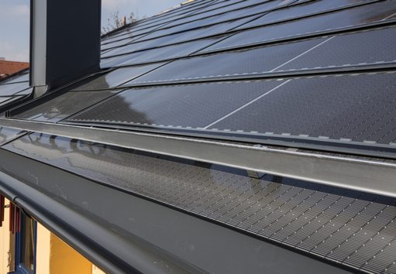
[13-18 cocuPV_roof surface]
Using “cocuPV”, architects can build a sealed roof surface with integrated photovoltaics.
Image: Boehme Systems Vertriebs GmbH

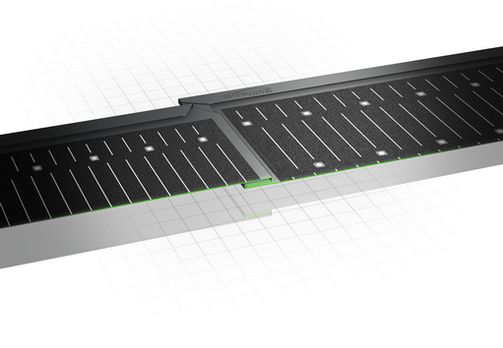
[13-18 cocuPV_connection]
Easy installation: the individual shingles can be fitted easily into each other along their edges and attached using the special clips from Boehme Systems.
Image: Boehme Systems Vertriebs GmbH

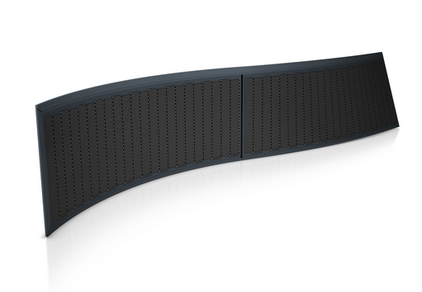
[13-18 shingle_cocuPV]
Thanks to its elasticity, even unusual, organic shapes can be formed using cocuPV.
Image: Boehme Systems Vertriebs GmbH
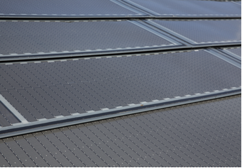
[13-18 Energy generation]
The roof can be used to generate energy without disturbing the appearance of the building by adding additional photovoltaic panels
Image: Boehme Systems Vertriebs GmbH

If you have any queries please contact:
BOEHME® SYSTEMS Vertriebs GmbH  Rafael Hein  Head of Marketing  Tel: +49 351 653 76 666  Email: presse@boehme-systems.com | Kommunikation2B  Mareike Quassowski | Andre Wand | GbR  Andre Wand  Tel: +49 231 530 70 411  Email: a.wand@kommunikation2b.de

