Press Release  Reprint free of charge. Press-cutting requested. | 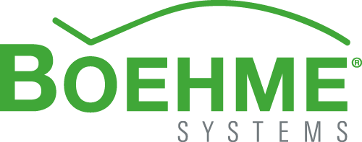

Energy generating metal roofing
Cost-effective roof restoration with cocuPV
Installing a new roof and improving the overall energy balance of the building at the same time: that was the aim owners of a detached building in Linz, Austria, had in mind for their single-family home. The feature that makes this roof special: cocuPV. The shingle with integrated photovoltaics not only provides a rather robust roof, it also generates energy! This makes an additional photovoltaics system obsolete.
Roofs are those parts of a building that last longest. Despite having to withstand a great many environmental stresses the roof may easily - if properly fitted – remain fully functional for up to 50 years. However, by the time bits of the roof cover become loose or the building starts showing signs of moisture and mould, it's high time for repair measures. Increasingly, the way a roof looks is not the only issue being taken into consideration. More and more energy efficiency is starting to play a key role in homeowners’ decision-making – as was the case in the roof restoration of this family home in Linz.

Metal shingles with integrated photovoltaics
The project’s pitched roof was damaged and was to be replaced with a modern metal covering. The homeowners desired an attractive looking yet sustainable solution. Rather than opting for a traditional roof cover with a photovoltaic system fitted on top, they chose to install cocuPV from Boehme Systems. This photovoltaic element consists of an integrated flexible solar module inside a metal shingle. This way the roof cover kills two birds with one stone: covering the building and generating energy.
Rapid installation progress
First the 145 m² large roof surface was covered and the roofing boards were inspected. Then the roof was fitted with permeable roof sheathing. Once the battens and counter battens had been fitted, the photovoltaic shingles, and thus the roof covering – were positioned in place in one single work step - as the use of cocuPV renders fitting an additional photovoltaic system obsolete. A fact that is of great benefit to owners, as it means shorter construction times which in turn means fewer labour hours and ultimately reduced labour costs.
Yet another plus point of integrated photovoltaics: the load exerted on the roof construction is minimised.
Thanks to these shingles’ angled profiles the elements can simply be slotted into one another and are then fastened with clips. The individual elements are fitted with a mounting film, which on one hand prevents premature electricity generation, while on the other protecting the material. So as to create a uniform overall look, any gaps are filled using dummy shingles. The end result is a closed, attractively looking roof that combines the advantages of photovoltaics and the material metal.
“With “cocuP” it becomes possible to realise a long-lasting roof that generates electricity. The ‘All Light Performance System’ ensures that electricity is produced even when the weather is less than favourable. Energy generation is thus not limited to times of pure sunshine”, explains Andreas Stengl, Managing Director of Boehme Systems Vertriebs GmbH.
In the future the home in Linz will be capable of producing around 3,800 kilowatt-hours of electricity per year with cocuPV, which corresponds to the average annual electricity consumption of a standard household.
Approx. 3,400 characters

About Boehme Systems:
Boehme Systems Vertriebs GmbH specialises in the development, manufacture and supply of innovative building claddings made from metal. The company sees itself as a system provider who develops solutions for facades and roofs that make architectural and economic sense, giving due consideration to all important surrounding factors. The products are manufactured in the company’s own production facilities which are equipped with state-of-the-art technologies. In addition to standardized solutions from its extensive product portfolio, Boehme Systems repeatedly develops individual solutions that offer architects and tradesmen a maximum degree of design freedom. A team of master tradesmen, fitting instructors, engineers and technicians ensure competent advice and service – from planning to execution.

Note:
This press release can also be downloaded at www.boehme-systems.com and www.Kommunikation2B.de.

Captions:
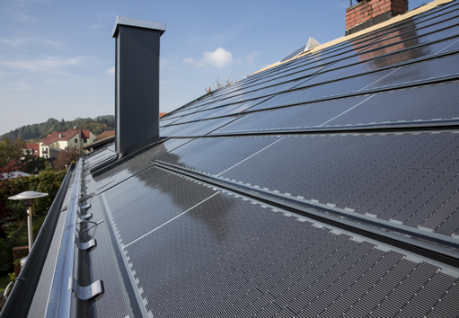
[13-23 Roof]
“cocuPV” creates aesthetically pleasing roofs that produce energy and aid sustainability.
Image: Boehme Systems Vertriebs GmbH

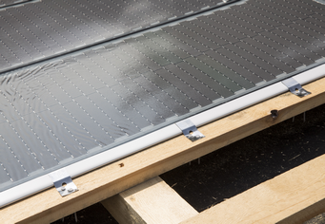
[13-23 Clips]
Angled profiles mean individual shingles can simply be slotted together and are then fastened with BOEHME® SYSTEMS clips.
Image: Boehme Systems Vertriebs GmbH

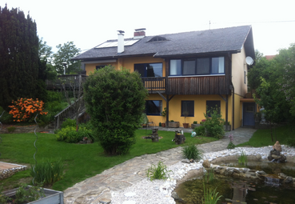
[13-23 Old roof cover]
The existing roof cover of this family home was outdated – the owners wanted to replace it with a modern and sustainable roof.
Image: Boehme Systems Vertriebs GmbH

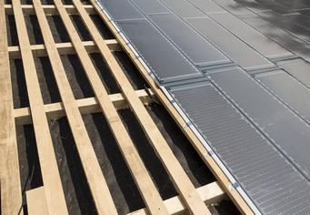
[13-23 Battening]
Prior to fitting the cover, battens and counter battens were installed.
Image: Boehme Systems Vertriebs GmbH

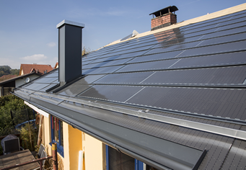
[13-23 Roof_new]
In future, the home in Linz will be producing around 3,800 kilowatt-hours of electricity per year.
Image: Boehme Systems Vertriebs GmbH

If you have any queries please contact:
BOEHME® SYSTEMS Vertriebs GmbH  Rafael Hein  Head of Marketing  Tel: +49 351 653 76 666  Email: presse@boehme-systems.com | Kommunikation2B  Mareike Quassowski | Andre Wand | GbR  Andre Wand  Tel: +49 231 530 70 411  Email: a.wand@kommunikation2b.de

