Press Release  Reprint free of charge. Press-cutting requested. | 

Elliptical Dome is ‘Cherry on the Cake’
Superb modern roof structure made from metal shingles adorns government building in Brunei
Since early 2013 one of the governmental buildings in the Sultanate of Brunei sports a new dome, i.e. the eye-catching new roof structure of the Prime Minister’s offices in the capital Bandar Seri Begawan. Incidentally, this is also where the 22nd ASEAN Summit was held in April 2013. The imposing architectural structure now has another attention-grabbing feature in its extraordinary elliptical dome. The shingle covers needed to be adapted first in order to produce a perfect fit for the dome’s geometry.
Brunei is a small country located in the north of the island of Borneo. In the mid 1990's construction works for a palace consisting of a central nave, flanked by two aisles, began.
However, shortly before the structural works were completed the project was aborted and the building shell abandoned. Then, in 2011, it was decided to resume and complete construction. Metal shingles from Boehme Systems were chosen for covering the roof.
Special Appearance of Roof Cover
While the barrel-shaped roofs of two flanking aisles were relatively easy to cover with shingles, the domed roofing was a separate specialist project in itself, because the dome bases are not round, but elliptical. The central dome is hemispherical with six flash lines. The two smaller domes are ellipsoids that also have six flash lines. The particular feature of an ellipsoid: the central line of an area delineated by the arrises does not run in an exact vertical line. This creates two uneven surface halves with a sloping roof appearance. This geometric feature is no longer visible in the finished roof construction.
In order to create an even and balanced roof it was therefore necessary to come up with a bespoke, specialist roof design. I.e., the shingle cover had to be adapted to produce a perfect fit for the dome’s geometry. Another challenge were fall protection system and step treads, which needed to be integrated into the sloping shingle assembly system that was designed for fitting shingles in a straight line.
A total of 8,000 m² of Classic Shingles from Boehme Systems were fitted in this project by the professional fitters of RC Building Technology Pte Ltd based on the special roof design images from Boehme. Since the aluminium shingles have an all-round seam, they could be fitted to the existing substructure with special hidden clips with absolute ease. This type of fastening ensures that the shingle itself does not have to be perforated with holes for screws or holes to attach other holding devices – which eliminates any kind of risk areas through which water could potentially enter.
So as to ensure a trouble-free project and a flawless result, a model of the dome was produced during joint extensive training sessions with the applicators which showed a section of the finished dome, including a section of the required flash line. The actual assembly was able to get underway on the basis of such comprehensive preliminary works. Starting from the centre of the dome, each dome segment was added one by one. Several teams working in parallel meant that the roof construction could be completed in just two and a half months.
The end result is a highly accomplished and impressive structure with the central dome being the icing - or to put it even more aptly - the 'cherry' on the cake. The nave houses a very spacious reception area, while the flanking areas house an event hall on one side, and a conference room and guest rooms as well as several offices on the other side.
Approx. 3,400 characters

About Boehme Systems:
Boehme Systems Vertriebs GmbH specialises in the development, manufacture and supply of innovative building claddings made from metal. The company sees itself as a system provider who develops solutions for facades and roofs that make architectural and economic sense, giving due consideration to all important surrounding factors. The products are manufactured in the company’s own production facilities which are equipped with state-of-the-art technologies. In addition to standard solutions from its extensive product portfolio Boehme Systems also frequently produces bespoke solutions, offering architects and tradesmen a maximum in design freedom. A team of master tradesmen, fitting instructors, engineers and technicians ensure competent advice and service – from planning to execution.

Note:
This press release can also be downloaded at www.boehme-systems.com and www.Kommunikation2B.de.

Captions:

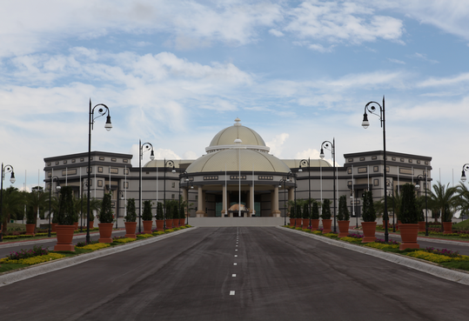
[14-08 Government Building]
A government building of particular grandeur: The Prime Minister’s offices in Bandar Seri Begawan.
Image: Boehme Systems Vertriebs GmbH

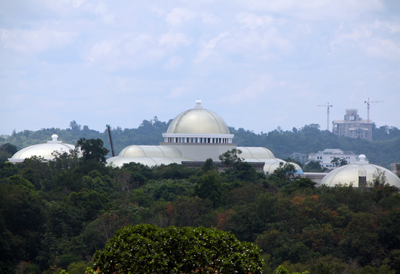
[14-08 Brunei]
An elaborate roof construction is the main feature of the building.
Image: Boehme Systems Vertriebs GmbH

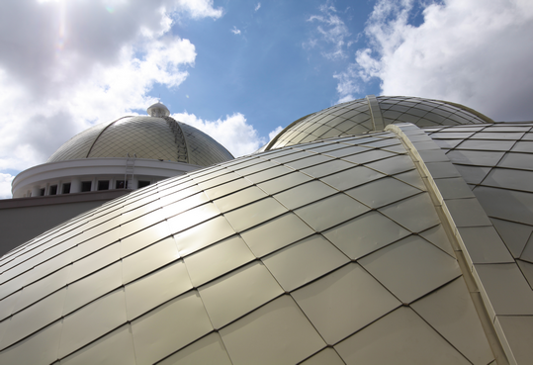
[14-08 Shingles_Brunei]
A total of 8,000 m2 of Classic Shingles from Boehme Systems were required for the dome.
Image: Boehme Systems Vertriebs GmbH

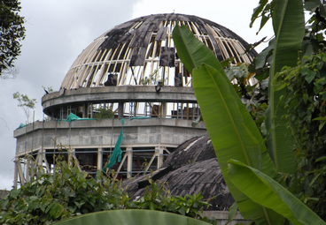
[14-08 Dome]
The construction of the palace began as early as the 1990s. However, shortly before the structural works were completed the project was aborted and the building shell abandoned.
Image: Boehme Systems Vertriebs GmbH

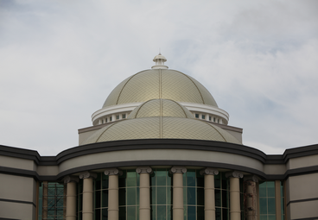
[14-08 Roof Appearance]
While the barrel-shaped roofs of two flanking aisles were relatively easy to cover with shingles, the domed roofing was a separate specialist project in itself.
Image: Boehme Systems Vertriebs GmbH

If you have any queries please contact:
BOEHME® SYSTEMS Vertriebs GmbH  Rafael Hein  Head of Marketing  Tel: + 49 89 24 20 63 07  Email: presse@boehme-systems.com | Kommunikation2B  Mareike Quassowski | Andre Wand | GbR  Andre Wand  Tel: +49 231 530 70 411  Email: a.wand@kommunikation2b.de

