Press information  Publication free of charge. Copy requested. | 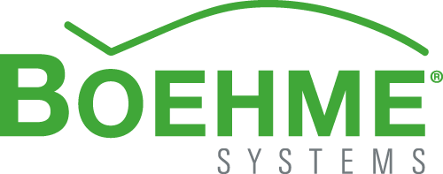

New look for metal shingles
Nubuck surface for roofing and façade
Boehme Systems’ aluminium shingles now get a new, appealing look with special textured paint. These new models with nubuck surface on request are available in the system provider’s standard colours for building shells. That surface does not only create a more appealing look, but also is scratch and abrasion-resistant.
Architects and planners have been relying on the building material metal for years – no matter if for façade solutions or roofing. Especially painted aluminium is often used for innovative and modern building shells. As a system provider for building shells Boehme Systems now extends their existing product range with a special surface, which reminds of leather. All classic shingles in the colours Cordia Red, Goura Grey and Criollo Brown are available featuring the new nubuck surface no matter if for diamond, square or rectangle shapes. The aluminium needed for the shingles‘ production already is being coil-coated with textured paint during its manufacturing. The primer followed by the textured paint is applied first so that a varnish thickness of 25 micrometre is obtained. The raw material is suited perfectly for the fabrication of Boehme Systems’ classic shingles as the alloy, the mechanical values and the coating system can easily be processed further as well as chamfered. The surface reminding of a leather structure stands out because of its scratch and abrasion resistance. The shingles additionally are classified in the fire resistance class A1 and therefore are well suitable for buildings underlying strict fire protection regulations.
Approx. 1,600 characters

About Boehme Systems:
Boehme Systems Vertriebs GmbH specialises in the development, manufacture and supply of innovative building claddings made from metal. The company sees itself as a system provider who develops solutions for facades and roofs that make architectural and economic sense, giving due consideration to all important surrounding factors. The products are manufactured in the company’s own production facilities which are equipped with state-of-the-art technologies. In addition to standardized solutions from its extensive product portfolio, Boehme Systems repeatedly develops individual solutions that offer architects and tradesmen a maximum degree of design freedom. A team of master tradesmen, fitting instructors, engineers and technicians ensure competent advice and service – from planning to execution.

Note:
This press release can also be downloaded at www.boehme-systems.com and www.Kommunikation2B.de.

Captions:

[14-26 Strukturlack]
On request Boehme Systems’ classic shingles already can be coated with special textured paint while in manufacturing.
Image: Boehme Systems Vertriebs GmbH

[14-26 Nubuk-Oberfläche]
The new surface structure gives Boehme Systems’ classic shingles a new unique look.
Image: Boehme Systems Vertriebs GmbH

If you have any queries please contact:
BOEHME® SYSTEMS Vertriebs GmbH  Rafael Hein  Leiter Marketing  Telefon: + 49 89 24 20 63 07  E-Mail: presse@boehme-systems.com | Kommunikation2B  Mareike Wand-Quassowski | Andre Wand | GbR  Andre Wand  Telefon: +49 231 530 70 411  E-Mail: a.wand@kommunikation2b.de

